This Data Analysis Report embarks on a detailed exploration of rejection and non-rejection emails, employing a methodical approach to uncover the linguistic and structural distinctions that define these communications. Through the lens of word frequencies, sentiment analysis, word count comparisons, and the examination of future action keywords, the report aims to decipher the strategic underpinnings of how organizations convey acceptance and rejection. By dissecting the content and tone of these emails, the analysis sheds light on the subtle ways in which companies seek to soften the impact of rejection, encourage future engagement, and streamline the integration of successful candidates. This investigation not only reveals the deliberate communication strategies at play but also provides a deeper understanding of how these practices contribute to the overall candidate experience and influence the efficiency of the recruitment process.

One of the first methods that I attempted was a comparative analysis of word frequencies and sentiment scores between rejection and non-rejection emails. This exploration used an examination of linguistic patters to attempt to uncover how rejection emails are not simply a notice of dismissal or rejection but seem to be more carefully crafted messages that utilise terms such as “unfortunately”, “interest”, and “position”. I believe that these choices are not simply incidental but are strategically used for an attempt of conveying empathy and maintaining a constructive tone. This could be done in an attempt to not burn bridges between the applicant and the company. This is further shows by the rather unexpectedly high average sentiment score of 0.7723. This highlights once again a deliberate effort to mitigate any potential sting of rejection while preserving a positive relationship with applicants. The use of such positive language hints at the underlying intent to encourage applicants to not take rejection too seriously thereby generating goodwill and leaving the door open for any future opportunities. In stark contrast to this non-rejection emails, which while also imbued with a very positive sentiment score of 0.7124, it is interesting to note that the average sentiment of the acceptance letters is actually lower than that of the rejection letters. As well as this they also adopt a more pragmatic and direct language style. Words such as “please”, “resume” and “team” dominate these communications implying a shift towards action and integration into the company. It seems clear that these terms more reflect a transition phase within the recruitment process. The accepted letters also have a higher appearance of the words “job” and “us” further emphasising the welcoming into the company. The nuanced use of language seems to serve multiple purposes. For those reject applicants words are carefully chosen to produce a positive tone in an attempt to cushion the blow from non selection. For those who have been accepted the language shits to prepare the ground for the next stages of engagement with a lower sentiment perhaps in an attempt to set expectations and create a sense of belonging.

The next method I would like to highlight was an investigation into the different word count distributions between rejection and non-rejection emails. This revealed a distinct pattern in the communications of rejected and non-rejection emails. Below is a box plot labelled figure 1 which will be referenced throughout this section.

Rejection emails, as show by Figure 1, have a notably lower median word count, with an average of around 80 words. This conciseness suggests a more uniform approach to creating such messages. This is likely driven by a need for clarity as well as the fact that in all likelihood a company needs to send more rejection letters than acceptance letters in a clear way that can handle large volumes of applicants efficiently. The more compact nature of these rejection emails is likely a deliberate choice designed to simply convey necessary information such as a brief acknowledgment of effort without prolonging the disappointment that is the email.  
Dissimilarly to this, non rejection emails display a broader range of word counts, with the average extending to approximately 106 words. This increase is not simply quantitative but qualitative as suggested by the prior section. The lengthier format of non rejection emails could be interpreted as a reflection of companies intention to initiate a dialogue with potential hires. The information given in the extra wordcounts could be information such as next steps, welcoming or integration into the greater organisation. Another interesting discovery made by the box plot is that on the lower end some non-rejection emails is in fact lower than that of the rejection emails. Furthermore on the upper end the highest wordcount non rejection email is significantly higher than that of the rejection being around 500 words to its 200. This change in the upper bracket could be the presence of a more personalised touch given that there will be significantly less accepted applicants to rejected applicants allowing for time to personally compose each email instead of using a set format. This analysis shows a statistically significant difference in word counts between rejection and non rejection emails highlighting that rejection emails are normally succinct while acceptance are often longer. This variance not only indicates functional differentiation in communications but also how organisations approach the candidate.

Figure 1

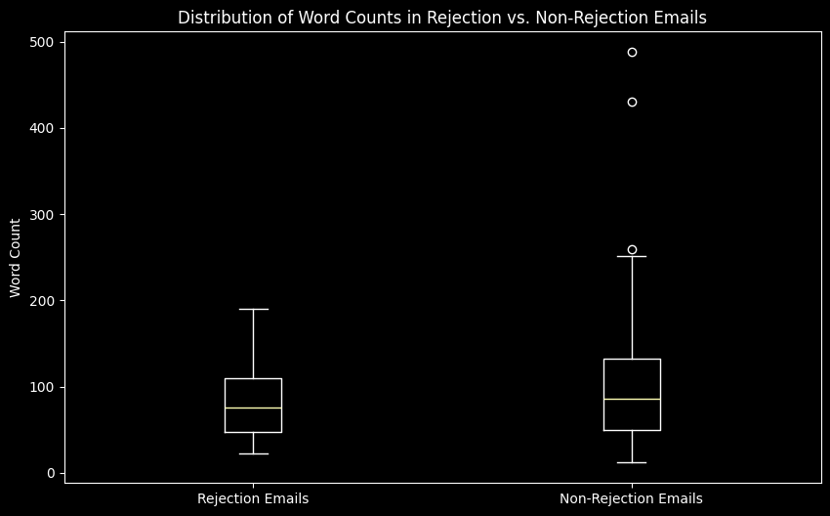

The final method that was employed was a dive into the use and frequency of future action keywords these keywords were "apply again", "future", "opportunities", "keep in touch", "update", "progress". This marked the largest disparity of any of the previous metrics between reject and non reject. With an average of 0.738 future action keywords per rejection email, it's evident that companies are not merely closing a chapter with a rejection but are instead laying the groundwork for potential future engagement. This strategic inclusion of future-oriented language serves multiple purposes. Firstly, it softens the immediate sting of rejection, cushioning the disappointment with a message of hope and ongoing value. Secondly, it signals the company's openness to revaluation and future opportunities, effectively keeping the door open for applicants who, although not the right fit at the moment, could be valuable assets down the line. This approach not only helps maintain a positive company image but also cultivates a talent pool that could be tapped into for future roles, thereby optimizing long-term recruitment strategies. Conversely, the significantly lower frequency of these keywords in non-rejection emails, averaging at 0.219 per email, highlights a different facet of recruitment communication. The scarcity of future action language in acceptance communications reflects the shift in focus from potential engagement to immediate action and integration. In this context, the primary goal is to facilitate a smooth transition for the candidate into their new role within the organization. The lack of emphasis on future opportunities or actions in these emails is indicative of the change in the company-candidate relationship; from potential employment to actual employment. The immediate next steps, logistical arrangements, and integration processes take precedence, leaving discussions of future possibilities to evolve naturally as part of the ongoing employee engagement and development processes. By analysing these differences, we gain insight into how companies manage the delicate balance between immediate recruitment needs and the cultivation of an engaged, positive community of current and potential candidates.

In this data analysis report, a multifaceted approach was utilised to dissect the linguistic and structural nuances of communications between rejected and non rejected emails. The findings reveal that rejection emails are infused with empathy, often with a higher sentiment score and future action keywords in order to maintain a relationship with the candidate. In contrast non rejected emails are characterised by a focus on immediacy and integration making use of pragmatic language and a more detailed narrative in the form of a higher wordcount to facilitate into their new role. This underlines the sophistication in which organisations navigate applicants balancing the need to efficiency with the creation of positive and engaging candidate experience. The strategies uncovered in this exploration highlight the nuanced manner in which companies manage the dynamics of acceptance and rejection. Furthermore regardless of the intent both rejection and acceptance have a high sentiment score creating goodwill.